2152 118 史君宝 编译原理 第五章作业 作业二

第一题：

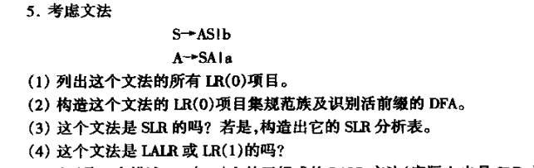

（1）解：

0. S’-> .S 1. S’-> S. 2. S -> .b 3. A -> S.A

4．A -> SA. 5. A -> .a 6. A -> a. 7. S -> .AS

8. S -> A.S 9. S -> AS. 10. S -> b. 11. A -> .SA

（2）解：

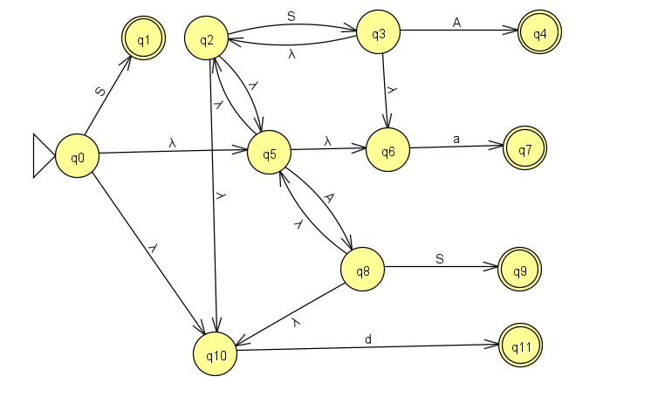

将其确定化：

|  |  |  |  |  |
| --- | --- | --- | --- | --- |
|  | S | A | a | b |
| {0,2,5,6,10} | {1,2,3,5,6,10} | {2,5,6,8,10} | {7} | {11} |
| {1,2,3,5,6,10} | {2,3,5,6,10} | {2,4,5,6,8,10} | {7} | {11} |
| {2,5,6,8,10} | {2,3,5,6,9,10} | {2,5,6,8,10} | {7} | {11} |
| {2,3,5,6,10} | {2,3,5,6,10} | {2,4,5,6,8,10} | {7} | {11} |
| {2,4,5,6,8,10} | {2,3,5,6,9,10} | {2,5,6,8,10} | {7} | {11} |
| {2,3,5,6,9,10} | {2,3,5,6,10} | {2,4,5,6,8,10} | {7} | {11} |
| {7} | Φ | Φ | Φ | Φ |
| {11} | Φ | Φ | Φ | Φ |

I0={S’-> .S, S -> .b, A -> .a, S -> .AS, S -> b.}

I1={S’-> S., S -> .b, A -> .a, S -> .AS, S -> A.S, S -> b.}

I2={S -> .b, A -> S.A, A -> .a, S -> .AS, S -> b.}

I3={S -> .b, A -> .a, S -> .AS, S -> A.S, S -> b.}

I4={S -> .b, A -> S.A, A -> .a, S -> .AS, S -> AS., S -> b.}

I5={S -> .b, A -> SA., A -> .a, S -> .AS, S -> A.S, S -> b.}

I6={A -> a.}

I7={S -> b.}

所以GO函数为：

GO(I0, a) = I6

GO(I0, b) = I7

GO(I0, S) = I1

GO(I0, A) = I2

GO(I1, a) = I6

GO(I1, b) = I7

GO(I1, S) = I3

GO(I1, A) = I4

GO(I2, a) = I6

GO(I2, b) = I7

GO(I2, S) = I5

GO(I2, A) = I2

GO(I3, a) = I6

GO(I3, b) = I7

GO(I3, S) = I3

GO(I3, A) = I4

GO(I4, a) = I6

GO(I4, b) = I7

GO(I4, S) = I5

GO(I4, A) = I2

GO(I5, a) = I6

GO(I5, b) = I7

GO(I5, S) = I3

GO(I5, A) = I4

项目集规范族为 C = {I1, I2, I3, I4, I5, I6, I7}

（3）解：

上述文法并不是SLR文法

其中状态1,4,5有移进规约冲突

其中状态1：FOLLOW(S’)={#} 不包含a,b

其中状态4：FOLLOW(S)={#,a,b} 包含a,b，移进规约冲突无法消解

其中状态5：FOLLOW(A)={a,b} 包含a,b，移进规约冲突无法消解

所以不是SLR文法